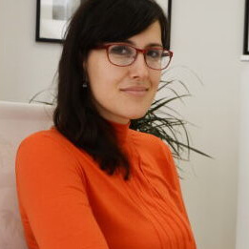

Marija M. Stanojevic Veselinovic works as Assistant professor at the Faculty of Education in Jagodina. She teaches several academic subjects in the area of Methodology of teaching German Language. She graduated at the Faculty of Philology and Arts, University of Kragujevac. She defended her PhD thesis at the same faculty in 2018.
She published many research papers in the journals and conference proceedings and participated in several national and international conferences. She has completed her professional development in the area of Teaching German several times abroad. She is the first associate of ÖSD Institut Rudjer Boskovic in Jagodina and faculty coordinator of Erasmus+ and CEEPUS programmes. Her main research activities are focused on methodology, phraseology, contrastive linguistic.

